Images to be inserted into Local Centers, Global Sounds Units
Unit 1: Wisconsin Lumberjacks, Their Work and History
All captions are in the word doc for the unit, where the photos are to be inserted.
Page 1: after the table of contents

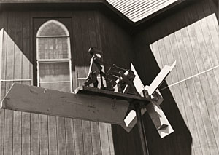
Wind-powered lumberjack, built by Eino Parkinen Photo: Matthew Gallmann, July 16, 1979

Page 6: right after “Shantyman’s Song”

Pages 9 – 10, INSERT: Crossword Puzzles (2)
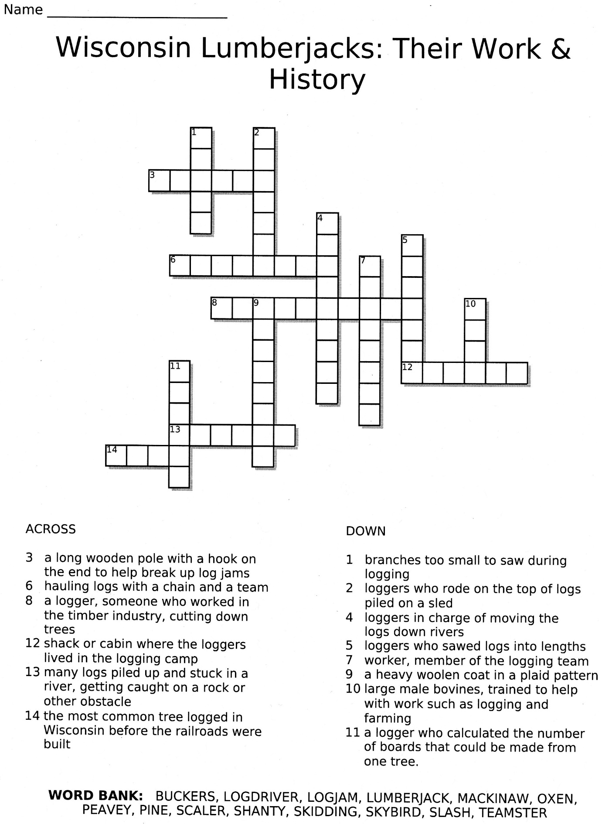
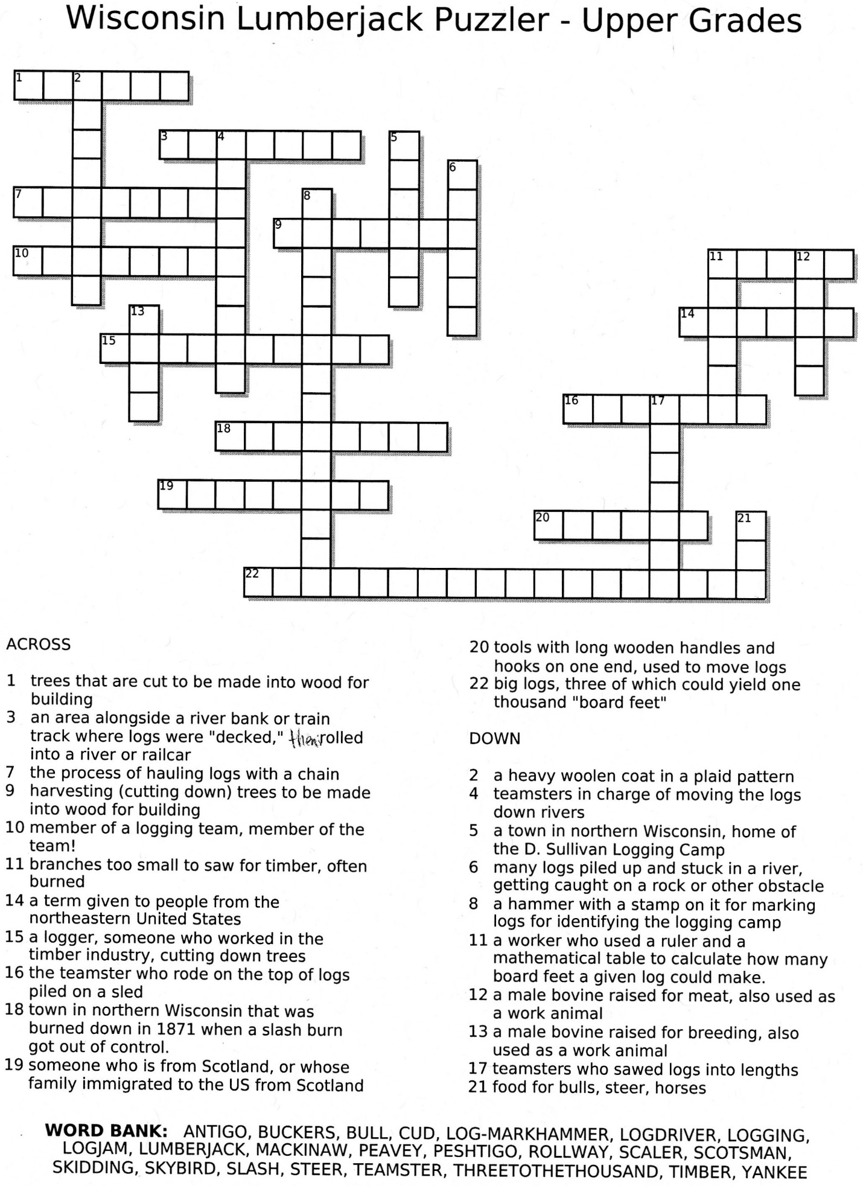
Page 11: INSERT: 1 page Crossword Puzzle Keys

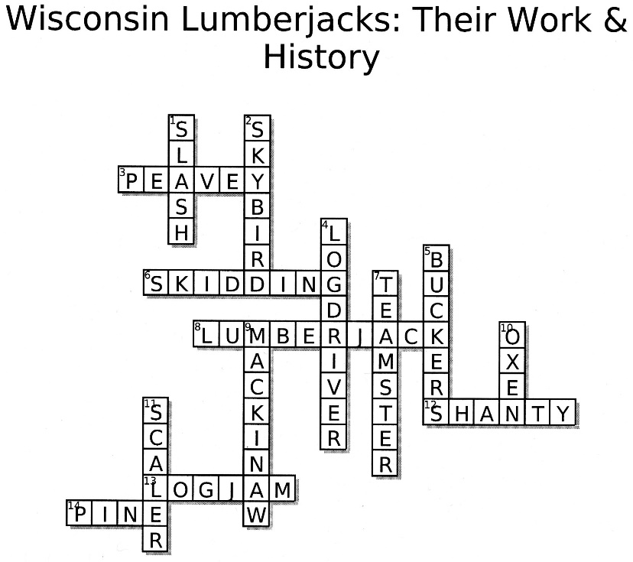

Pages 13 – 14, INSERT: Two Venn Diagrams (2 song and 3 song)
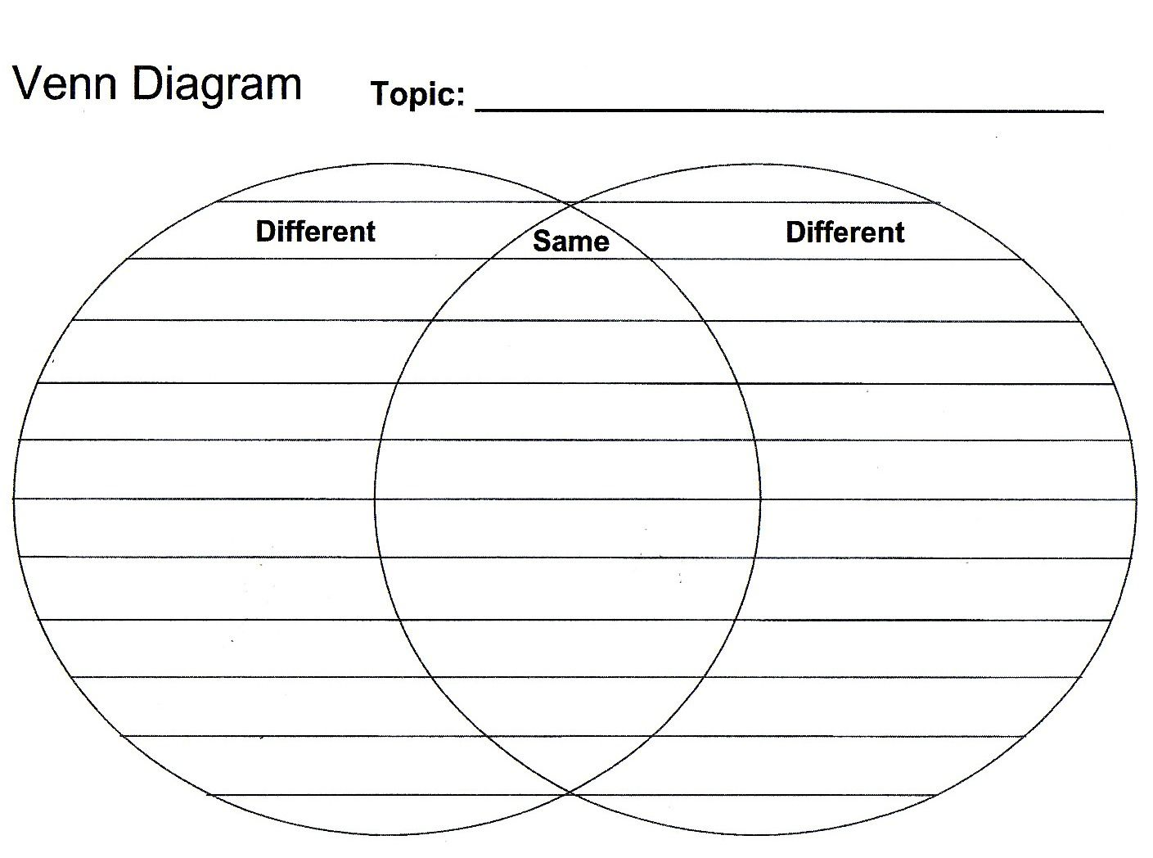

P. 15 – INSERT Examples of student acrostic poems (cut and paste together to fit on one page)
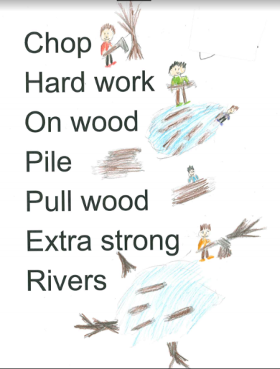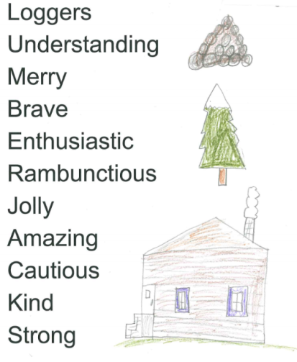

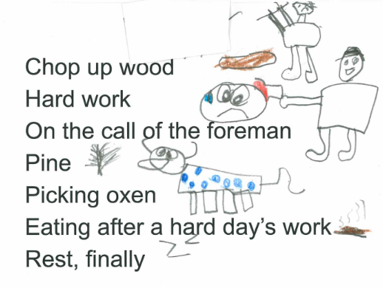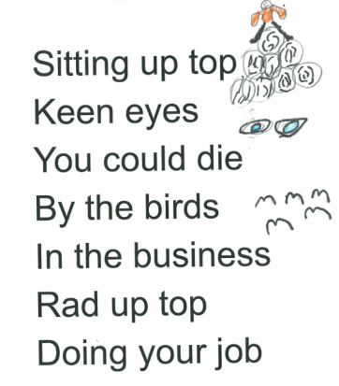

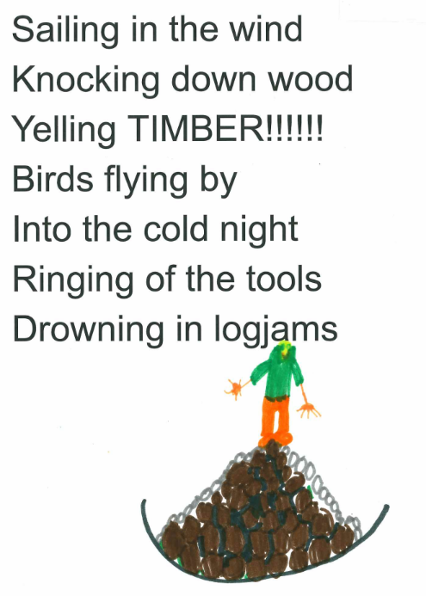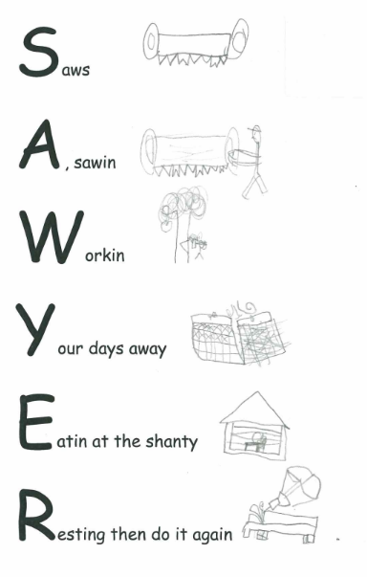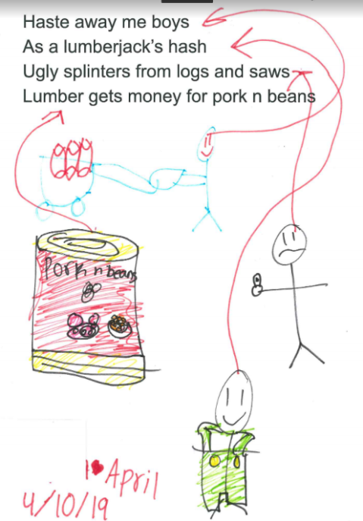

Page 16 – Otto R. on cigar box fiddle, right after “Hounds in the Woods”

