Images and notes for insertion – Unit 3, Wisconsin Songs of the Spirit

P. 1 – INSERT Happy Harmonizers
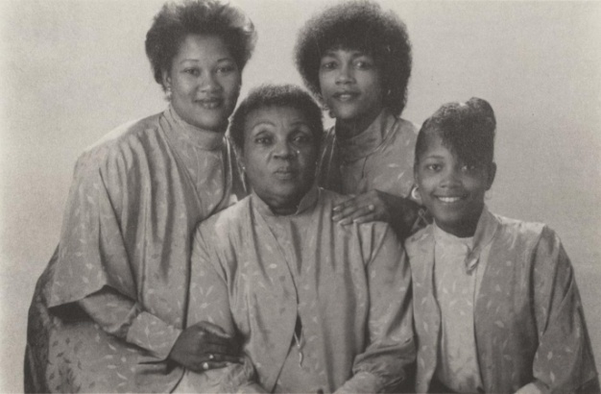
Happy Harmonizers. An a cappella gospel group from Milwaukee. (Local Centers/Global Sounds: Historic Recordings and Midwestern Musical Vernaculars). https://digital.library.wisc.edu/1711.dl/ZKJNVYU342LAT8S

P. 5 – INSERT Lillian Greene and friend
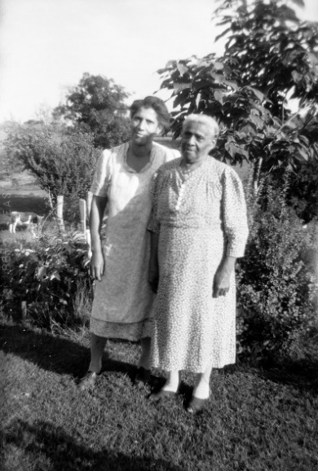
Lillian Greene (on right, and unidentified woman), Lancaster, Wisconsin, 1946
(Leary, 2015, p. 259, from Wisconsin State Historical Society)

P. 6 – INSERT St. Stanislaus Polish Catholic Church, Milwaukee
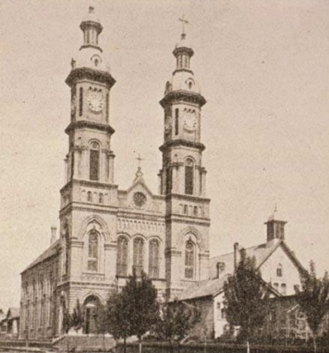
St. Stanislaus Polish Catholic Church. Milwaukee, Wisconsin
(https://digital.library.wisc.edu/1711.dl/WMFVAMUXVXP758Y)

P. 7 - INSERT Hmong man with a qeej
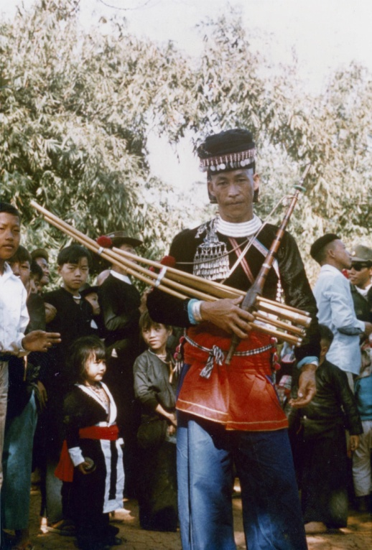
A Hmong man with a qeej musical instrument in Houa Khong Province. Photography by James Bowman, 1973. (William W. Sage collection on Laos). https://digital.library.wisc.edu/1711.dl/Z4B3INPY3EUNV8W

P. 12 – INSERT Crossword puzzle (enlarge to fit page)

P. 13 – INSERT Puzzle Key

PP. 15 – 16 Venn Diagrams (for 2 and 3 songs)

