UW-Madison Libraries: Introduction to Plagiarism

1. Plagiarism

1.1 Introduction
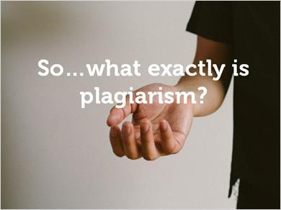
Transcript:
So…what exactly is plagiarism? Essentially, it’s using someone else’s ideas without crediting them in your work.

1.2 Plagiarism Video

1.3 Explore Further
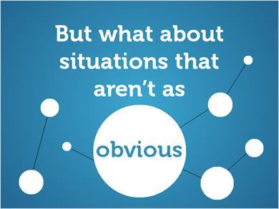
Transcript:
But what about situations that aren’t as obvious? There are lots of ways that you can plagiarize even when you don’t think what you’re doing is plagiarism. Let’s look at a few examples.

1.4 Intellectual Property
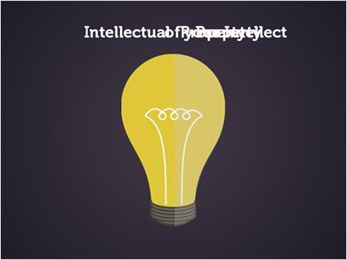
Transcript:
Have you ever heard your instructors refer to the concept of “intellectual property”? A simple definition of intellectual property is an idea or piece of writing that you’ve created with your mind. Another way to phrase it: It’s the property of your intellect!

1.5 Intellectual Property Analogy
Transcript:
Sometimes concepts are easier to understand when considering a concrete example, so let’s compare intellectual property to a physical object, like a cellphone. Your phone is valuable to you because it allows you to communicate with other people in various ways.

1.6 Intellectual Property Value
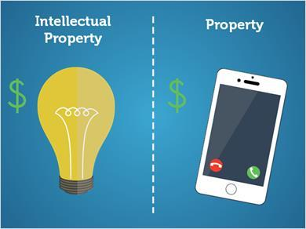
Transcript:
In a similar way, the pieces of your intellectual property, like papers, research, and projects you turn in for class are valuable because they allow you to earn academic credit. So just like a phone, information and intellectual property are valuable because of what you gain from them and what they allow you to do.

1.7 Comparison
Transcript:
Now that we know what intellectual property is and that information has value, let’s look at plagiarism and how it relates to intellectual property.

1.8 Intellectual Burglary
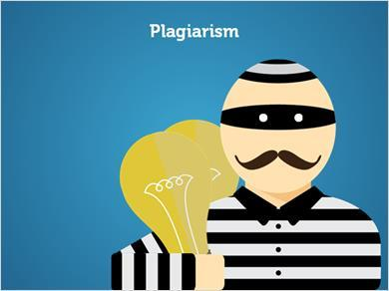
Transcript:
The UW-Madison Writing Center describes plagiarism as a form of intellectual burglary where someone “steals” ideas or writings from someone else and presents them as their own.

1.9 Comparison
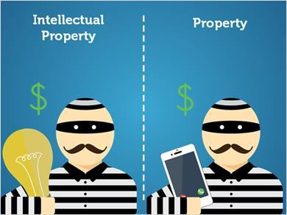
Transcript:
Let’s go back to our cellphone example. You know that taking someone else’s phone without their permission is considered stealing, so it makes sense that using someone else’s ideas or work without citing them is also stealing.
Plagiarism isn’t always that simple, though. Let’s take a look at how plagiarism can sometimes be unintentional.

1.10 Example 1
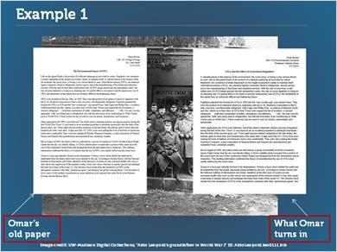
Transcript:
Omar has a paper due tomorrow on World War I. Omar took a class last semester that covered World War I in greater detail, so he decides to save a little time and re-use some parts from the final research paper he wrote for that class.
Omar makes a few changes to the material he uses from the first paper, but for the most part he reuses these sections without changing anything.

1.11 Knowledge Check
(Multiple Choice, 0 points, 1 attempt permitted)
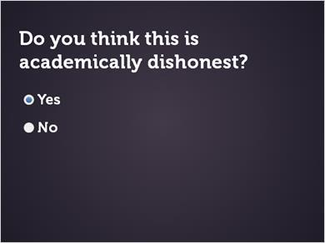
Correct | Choice
X | Yes
 | No
Feedback when correct:
That’s right! By reusing parts of his paper from last semester, Omar is committing self-plagiarism and acting in an academically dishonest way.
Feedback when incorrect:
That’s not right, sorry! By reusing parts of his paper from last semester, Omar is committing self-plagiarism and acting in an academically dishonest way.

Transcript:
Do you think this is academically dishonest?

1.12 Closer Look
Transcript:
Let’s take a closer look: Omar has already turned in parts of this paper (his intellectual property) for credit in another class, so he’s acting dishonestly by “recycling” them for credit in this class.

1.13 Closer Look
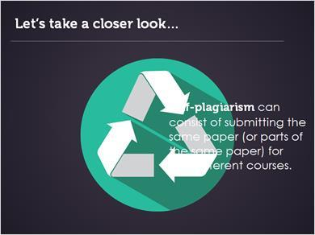
Transcript:
Self-plagiarism, sometimes called ”recycling,” might be new to you. It can be tricky to define, but in the academic context, it can consist of submitting the same paper--or parts of the same paper--for two different courses. This is considered plagiarism by many universities and colleges because you’re earning credit twice for only doing the work once.

1.14 Example 2
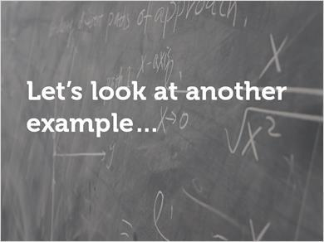
Transcript:
Let’s look at another example.

1.15 Example 2
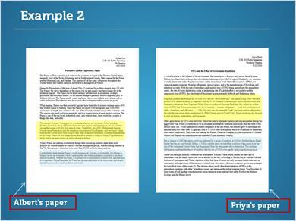
Transcript:
Two students, Albert and Priya, are working on their papers for a class. Albert asks Priya a question about the paper. She shows him part of her paper to help explain her answer and they discuss the paper together. Albert then uses phrases in his paper that are almost exactly the same as what Priya has written in hers.

1.16 Knowledge Check
(Multiple Choice, 0 points, 1 attempt permitted)
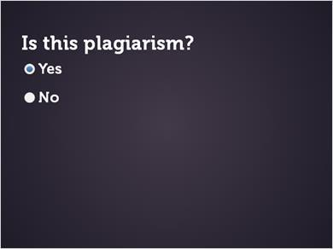
Correct | Choice
X | Yes
 | No

Feedback when correct:
That’s right! Even though Albert didn’t mean to copy the ideas and phrasing in Priya’s paper, the paper he turned in is still plagiarized.
Feedback when incorrect:
That’s not right, sorry! Even though Albert didn’t mean to copy the ideas and phrasing in Priya’s paper, the paper he turned in is still plagiarized.

Transcript:
Is this plagiarism?

1.17 Closer Look
Transcript:
Let’s take a closer look: It’s okay for you to talk about papers with classmates (unless your instructor says otherwise), but make sure that the papers you turn in contain ideas that are written in your own words.

While this isn’t the case everywhere, universities in the United States require giving other scholars credit if you use their ideas in your own paper because their ideas are their intellectual property.

1.18 Closer Look
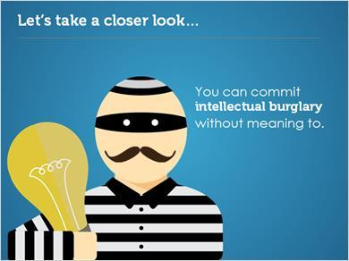
Transcript:
Like we talked about earlier, information is valuable, and the information and work you create is your intellectual property. Using other people’s ideas as your own without putting them in your own words or citing them is basically intellectual burglary, even if you didn’t mean to steal it.

1.19 So What?
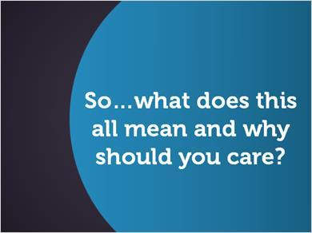
Transcript:
So…what does this all mean and why should you care?

1.20 So What?
Transcript:
Producing your own work and research without plagiarizing makes you a stronger and more capable scholar, and you can take pride in knowing that your work is original.

1.21 Review
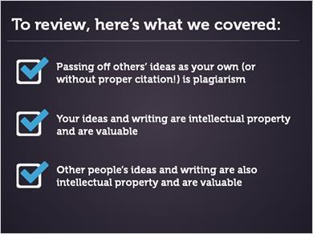
Transcript:
To review, here’s what we covered:

-Passing off others’ ideas as your own (or without proper citation) is plagiarism
-Your ideas and writing are intellectual property and are valuable
-Other people’s ideas and writing are also intellectual property and are valuable

2. Contextomy

2.1 Context
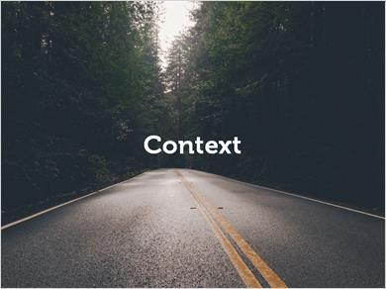
Transcript:
In this section, we’ll talk about how context impacts the meaning of information

2.2 Example 1
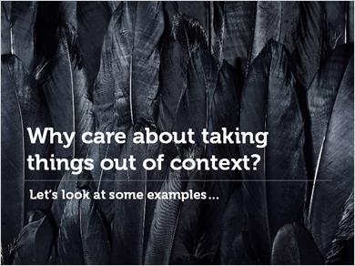
Transcript:
Why care about taking things out of context? Let’s look at some examples…

2.3 Movie Poster
Transcript:
Notice anything strange about this movie poster?

2.4 Two Stars
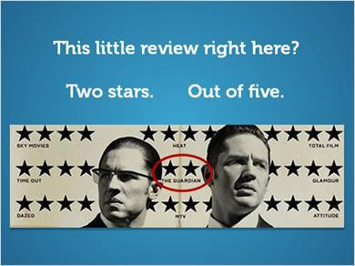
Transcript:
This little review right here? Two stars. Out of five.

2.5 Misleading Information
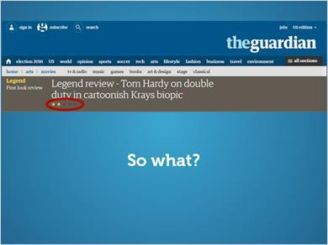
Transcript:
Misleading? Sure. So what?

2.6 Context
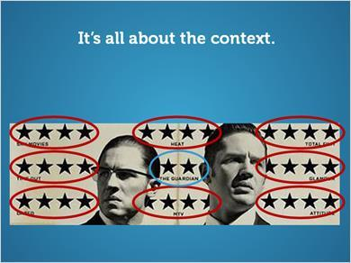
Transcript:
It’s all about the context. Surrounded by the other reviews, we’re led to believe that this is also a four-star review.

2.7 Bad Review
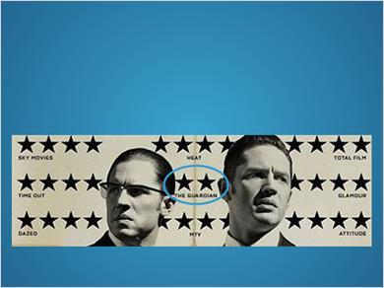
Transcript:
But the author’s intent in The Guardian review was anything by glowing.

2.8 Review Quotation
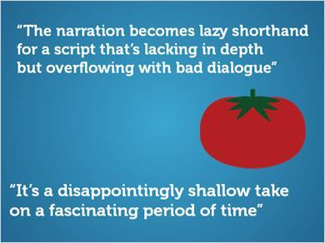
Transcript:
“The narration becomes lazy shorthand for a script that’s lacking in depth
but overflowing with bad dialogue”

“It’s a disappointingly shallow take on a fascinating period of time”

2.9 Review Quotation
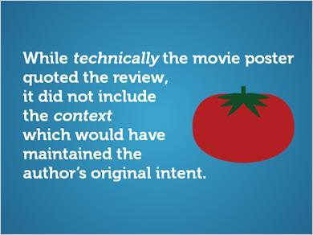
Transcript:
While technically the movie poster quoted the review, it did not include the context which would have maintained the author’s original intent.

2.10 Example 2
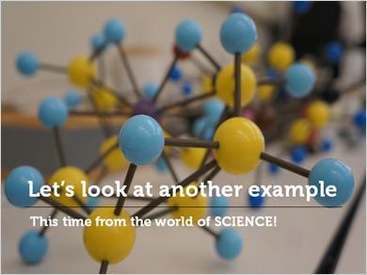

Transcript:
Let’s take a look at another example. This time from the world of science!

2.11 Last Week Tonight
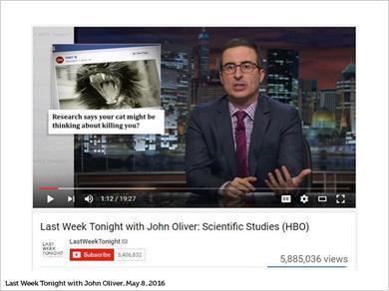
Transcript:
On Last Week Tonight, host John Oliver featured some scientific studies that made the news.

2.12 News Article
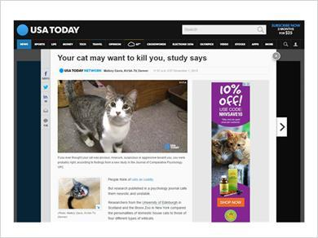
Transcript:
One headline featured a study that supposedly found your cat may want to kill you.

2.13 Research Article
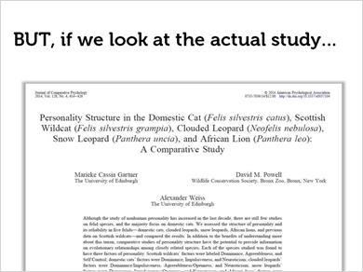

2.14 Research Article Highlights
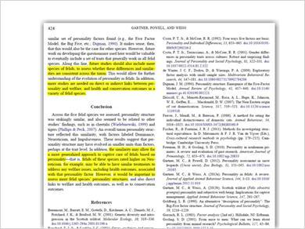
Transcript:
But if we actually look at the study, we see that wasn’t at all what the researchers discovered!

2.15 Research Article Context
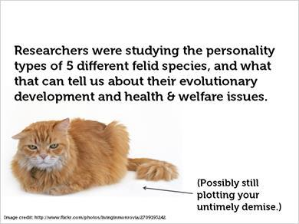
Transcript:
The researchers were studying the personality types of 5 different felid species, and what that can tell us about their evolutionary development and health & welfare issues.

2.16 How did this happen?
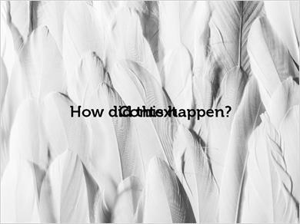

Transcript:
How did this happen? Context.

2.17 Original Intent
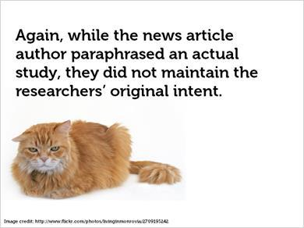
Transcript:
Again, while the new article author paraphrased an actual study, they did not maintain the researchers’ original intent.

2.18 T/F Quiz
(True/False, 10 points, 1 attempt permitted)
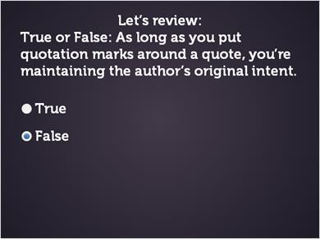
Correct | Choice
 | True
X | False

Feedback when correct:
That's right! Context affects how information is understood, so you must also include the context to maintain the author’s original meaning.
Feedback when incorrect:
Context affects how information is understood, so you must also include the context to maintain the author’s original meaning.

2.19 Searching Out Of Context
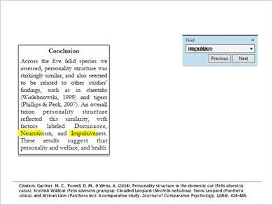
Transcript:
Taking things out of context can happen when writing papers, too.

2.20 Research Out Of Context
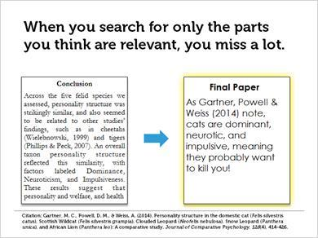
Transcript:
When you search for only the parts you think are relevant, you miss a lot.

2.21 Information Context
Transcript:
Information always has context.
By using it, we remove it from its original context. And that’s ok. However…
It’s critical to maintain the author’s original intent.

2.22 Telephone
Transcript:
Like the game ‘Telephone,’information can get distorted as it passes from one source to the next. Be sure you understand the context before pulling a quote from a source.

2.23 Understand Context
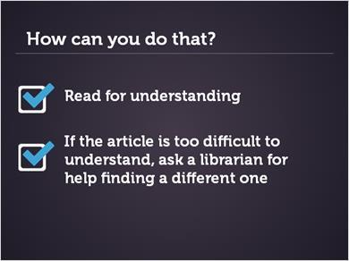
Transcript:
How can you do that? Read for understanding. Scholarly articles aren’t romance novels. Slow down, underline, jump around, reread. Ask for help-from a librarian, a professor, a trusted friend. And if the article is too difficult to understand, ask a librarian for help finding a different one.

2.24 Review
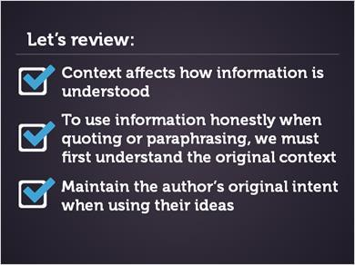
Transcript:
Let’s review. Context affects how information is understood. To use information honestly when quoting or paraphrasing, we must first understand the original context. Maintain the author’s original intent when using their ideas.

2.25 Plagiarism Resources
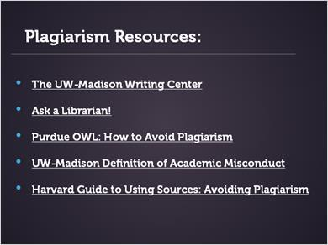
Transcript:
Want to learn more about avoiding plagiarism or need more help?
Check out these resources!

